**Live relative cover: Presence/Absence**

Biotic Crust Class: Live sagebrush is present at all levels of biotic crust class, but most occur at the middle to lower classes. They are absent when biotic crust class is absent (class 0), or not well developed (classes 1&2).

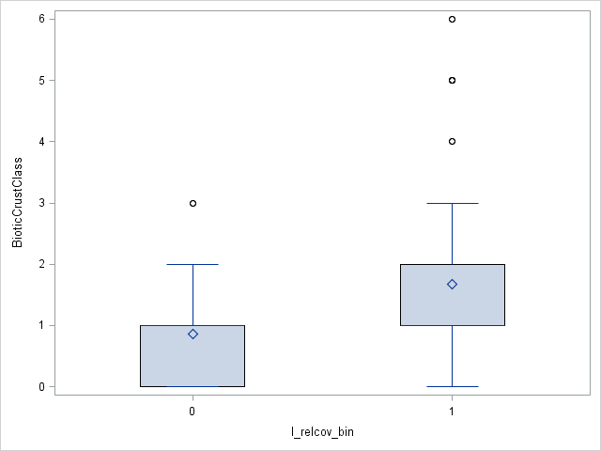

Pedon Depth: While live sagebrush occur throughout the range of pedon depths, they are more likely to be absent at deeper sites between 100cm and 200+cm.

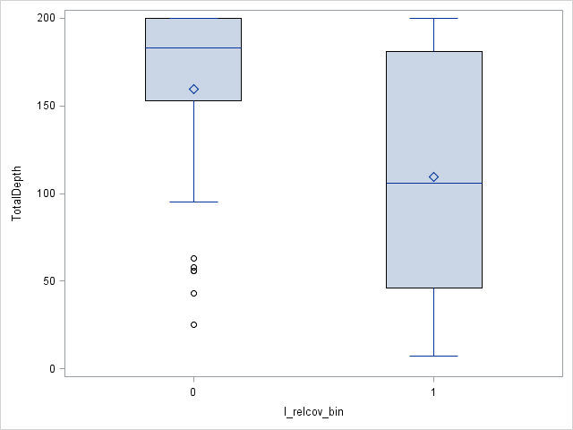

Surface Horizon pH: Live sagebrush is found throughout the range of sampled pH, but is more likely to occur when pH approaches neutral.

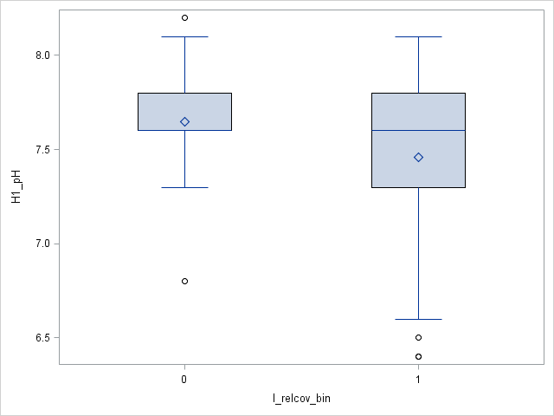

**Live relative cover: Logit Transformed**

Biotic Crust Class: In general, relative cover increases as biotic crust class increases

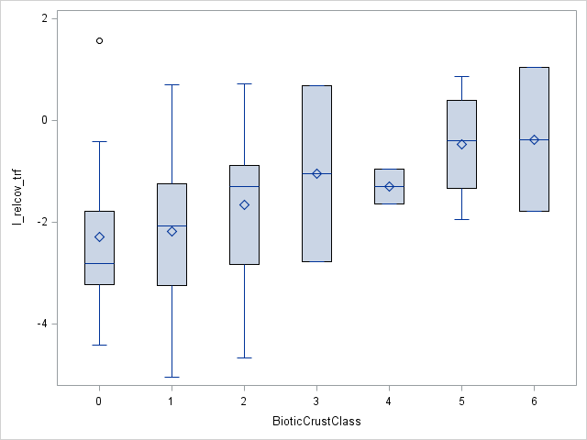

Surface Horizon pH: Holding BCC constant, relative cover generally decreases as pH increases.

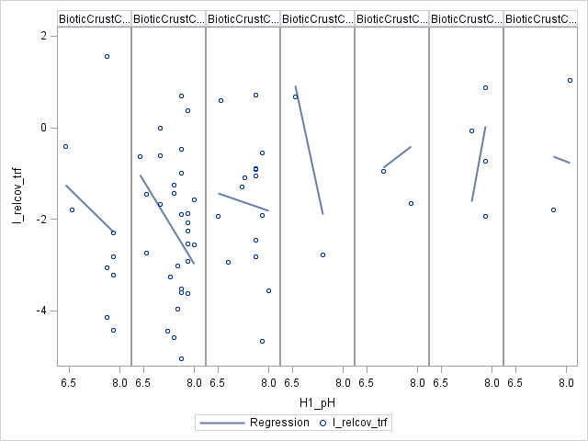

Surface Horizon Clay Percent (natural log (ln) transformed): Across the biotic crust classes, relative cover increases as surface horizon clay percent increases.

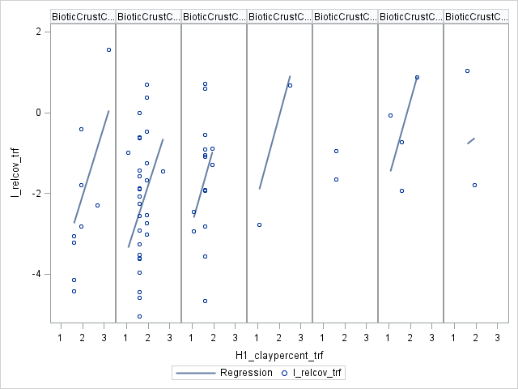

**Dead relative cover: Presence/Absence**

Biotic Crust Class: Dead sagebrush is present at all levels of biotic crust class, but most occur at the middle to lower classes. Absences occur when biotic crust class is absent (class 0), or not well developed (classes 1&2).

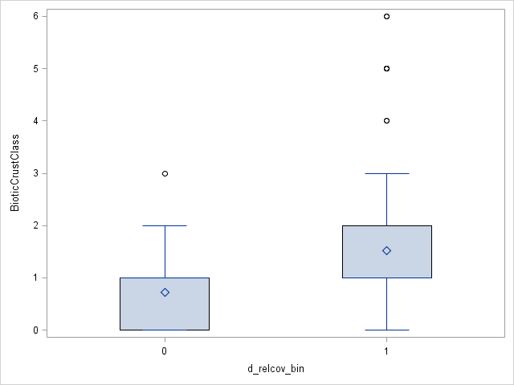

Pedon Depth: While sagebrush carcasses are present throughout the range of pedon depths, they are more likely to be absent at the deepest sites (>150cm).

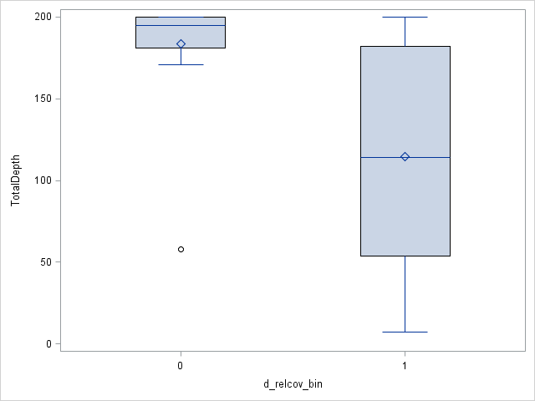

**Dead relative cover: Logit Transformed**

Surface horizon Dry Hue: The relative cover of sagebrush carcasses generally increases as the soil becomes redder and less yellow.

